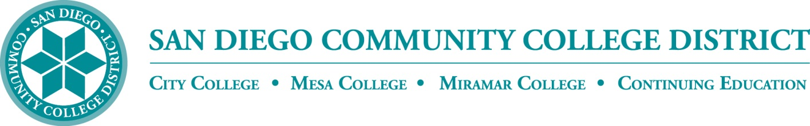**BP 4023**

**Board Policy**

Chapter 4 – Academic Affairs

**BP 4023 COURSE MATERIALS ADOPTION AND PROCUREMENT**

**References:**

No specific references

~~This policy is intended to provide standards for~~ The following standards support the adoption and procurement of affordable textbooks and other course materials that support academic freedom and educational quality while promoting cost-effectiveness in the selection of course materials.

1. **Course Materials**

All materials necessary for the successful completion of a class, either required or optional. Includes:

1. **Required Textbooks** – Includes all hardback and paperback books, manuals, lab manuals, e-books, and workbooks.
2. **Supplemental Materials** – Includes materials that supplement the basic textbook, website access codes, clickers, e-books, and course-specific software. These may be required or optional.
3. **Other Materials** – Includes but are not limited to course specific supplies, specialized clothes, music, film, electronic storage devices, and safety gear.
4. **General Policy**
5. All textbooks and instructional materials are selected by faculty.
6. Required course materials will be specified in the syllabus for each class and listed in the online schedule of classes.
7. Textbooks and supplemental materials must be accessible to students with disabilities in order to comply with state and federal laws.
8. Faculty shall submit the required information and/or order textbooks and instructional materials in accordance with published deadlines to ensure that:
9. The information can be listed in the online class schedule;
10. The bookstore can procure the most cost-effective options for students; and
11. DSPS has sufficient time to procure accessible alternatives as needed.

Faculty should not list, as required, course materials if there is uncertainty that the item will actually be used.

1. The direct sale of textbooks and other instructional materials or supplies to students, by faculty or staff, is prohibited.
2. Neither individual faculty, nor programs/departments, inclusively, may accept incentives from publishers or their representatives offered as inducements for the consideration and/or adoption of textbooks or other instructional materials, other than reduced costs on textbooks or other instructional materials that directly benefit students.
3. Faculty will make every effort to look for the most cost-effective option when choosing course materials without compromising the quality or integrity of the course.

~~Adopted: March 14, 2013~~

~~Supersedes: New Policy 3306 – 2/10/11~~

Also see AP 5031 titled Instructional Materials Fees and BP/AP 6900 titled Bookstores

***NOTE:*** *This policy is unique to the San Diego CCD. The language in* ***black ink*** *is from current SDCCD BP 3306 titled Course Materials Adoption and Procurement adopted on February 10, 2011 (as Policy 3306) and revised on March 14, 2013 (as BP 3306). The language in* ***blue ink*** *is included for consideration.*

|  |  |
| --- | --- |
| **Adopted:** February 10, 2011 (as Policy 3306)  **Revised:** March 14, 2013 (as BP 3306); ______ |  |
| *(Replaces current SDCCD BP 3306)* |  |

**Legal Citations for BP 4023**

No specific references